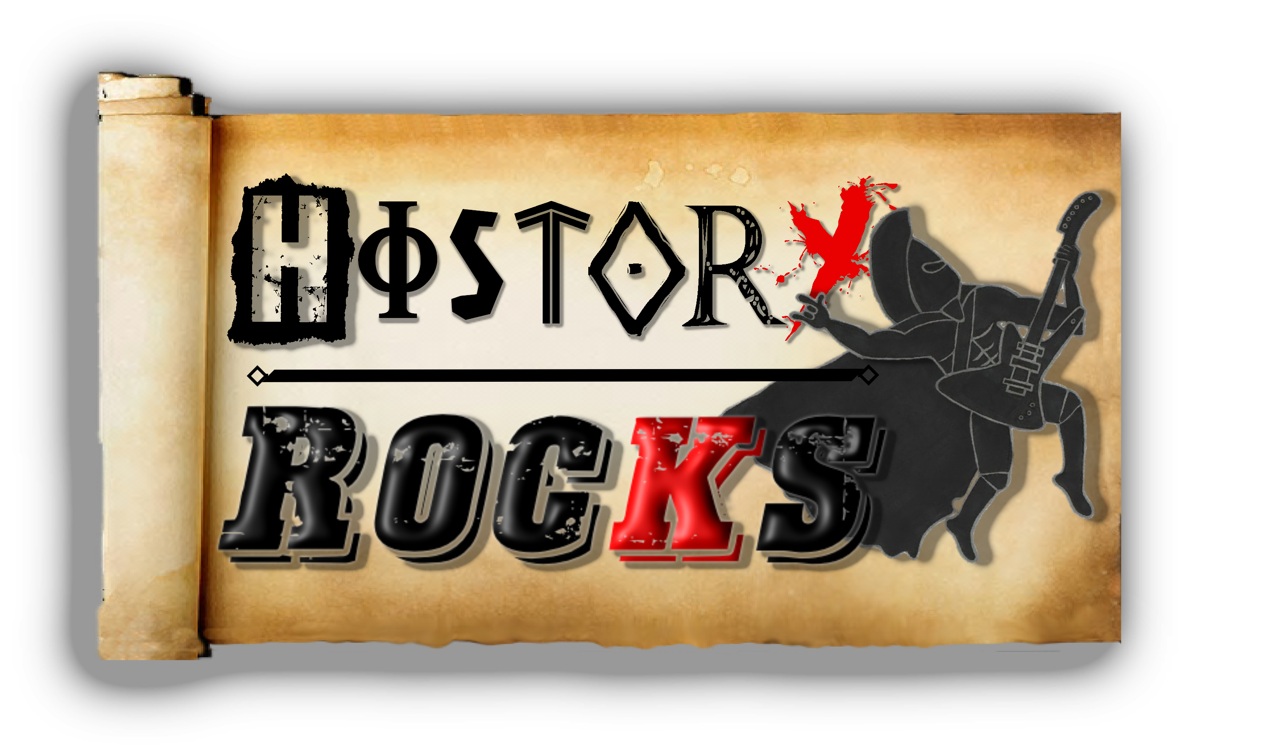
Mayans – Gods And Sacrifice
Itzamna, God that wrote
Ekchuah, God of chocolate
Kukulkan, brings the elements
Ixtat-Ix, gives intelligence

Pre-chorus (repeated)

Chorus (repeated)

Up to the top of the temple you go
The ceremony starts with an offering so
We'll rip out your heart from a cut to the throat
If we're sacrificing you or sacrificing a goat

Pre-chorus (repeated throughout)
Woah-oh - the gods see us grovelling
Woah-oh - sacrifice our offering
Woah-oh - decorate our giving blue
Woah-oh - it's just what we Mayans do

Chorus (repeated throughout)
Don't mind us, we're the Mayans
And we love blood
All we give's for the gods, our Lords above
Don't mind us, it's what we do,
Sacrificing things all blue

So many ways our offerings go
We'll dance and stab you in the heart with wooden arrows
We'll fill you up with some silver and gold
Toss you in a pool and we'll see if you float

Pre-chorus (repeated)

Chorus (repeated)

