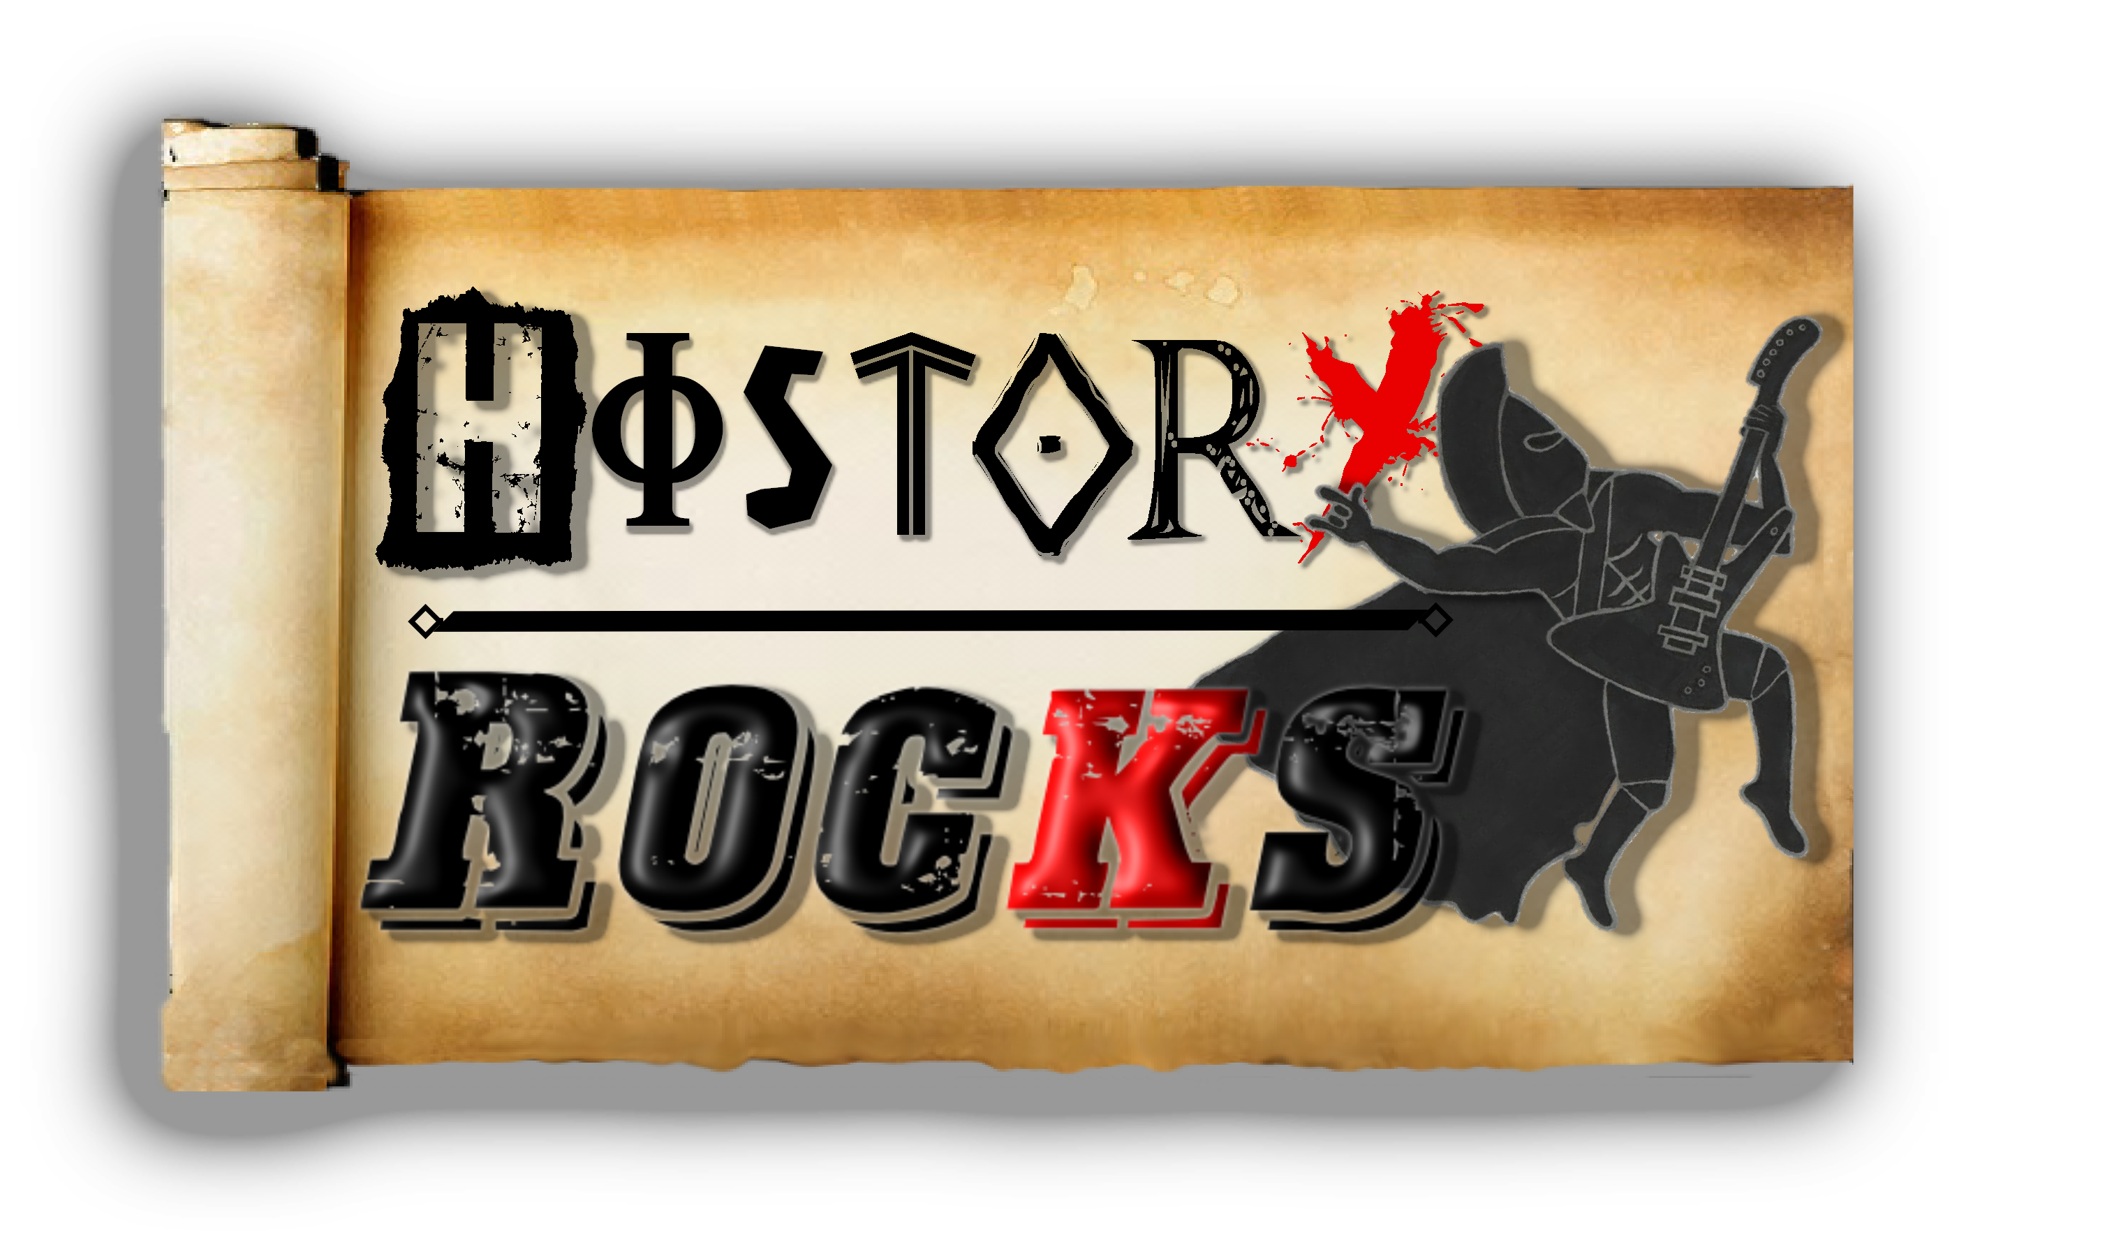
British Monarchy – Kings and Queens
William started it
In 1066
Hastings won
And the Domesday exists
John lost his power
When he signed a charter
Power restricted
By Magna Carta
Edward come
We need your help
The Scottish are rebelling
And so are the Welsh
Edward please
We need reform
The justice system’s ageing
And needs an overhaul
Chorus
British Monarchy
You’re serving your King or Queen
You better pay respect
You better pay it to
I won't tell you twice
You better fall to your knees

Henry Fifth
Went to France and to war
Beat the French up
At Agincourt

Henry Seventh
Loved his peace and taxes
Restored wealth
And Britain's finances

Henry Eighth
He had 6 wives
Divorced, beheaded, died
Divorced, beheaded then survived

Henry please
The church is mad
Divorce can make you fat of course
And your cholesterol is bad

Chorus

Elizabeth refused to marry
You see
“I'm married to England
And prosperity”

James ruled the Scots
And the English too
He was close to demise
When Parliament nearly blew

Charles started a civil war
Then Cromwell was Lord Protector

Meet your Queens
Victoria
Her empire was so vast
And Britain superior

Elizabeth
Rules righteously
Our longest reigning monarch
From the Windsor dynasty

Chorus

