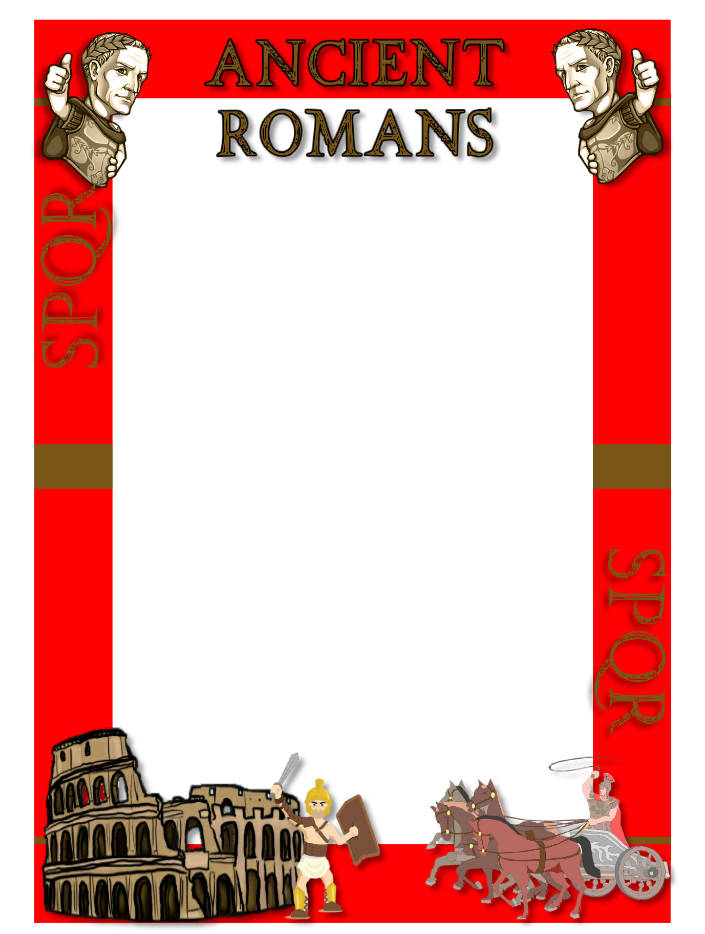

Hadrian

HYPOCAUST (Roman central heating)

30km/20miles

Testudo

Pedagogue

Stylus

Poseidon

Underworld

Castellum

Aqueduct

Circus

Chariot

Scorpio

Onager

Gladius

Pilum

Greek

Y

16

The word to find is:

9. Name the tortoise shape used by the army:

How far might a roman soldier walk each day?

8. Name the metal pointed object useD to write with?

What was the name of a well educated slave?

7. Where did roman spirits go to when they died?

What was Neptune’s Greek name?

6. What carried Fresh water into the cities?

What was the main tank of water called?

1. Who BUILT a wall to stop the picts?

How many forts were built along the wall?

5. What type of cart was used for racing?

What was the proper name for a race track?

4. Name the Roman catapult beginning with ‘o’?

What was the name of the ‘Dart Thrower’?

Find and then scan the QR codes to write down the answer to each question. The first letter of each Red answer will give you a word. When you have collected all of the answers, answer the GOLD questions for bonus points!

3. What was the proper name for the Soldier’s javelin?

What was the name of the Roman sword?

2. Which symbol was used for the latin letter ‘I graeca’?

Which other language did Romans often speak?