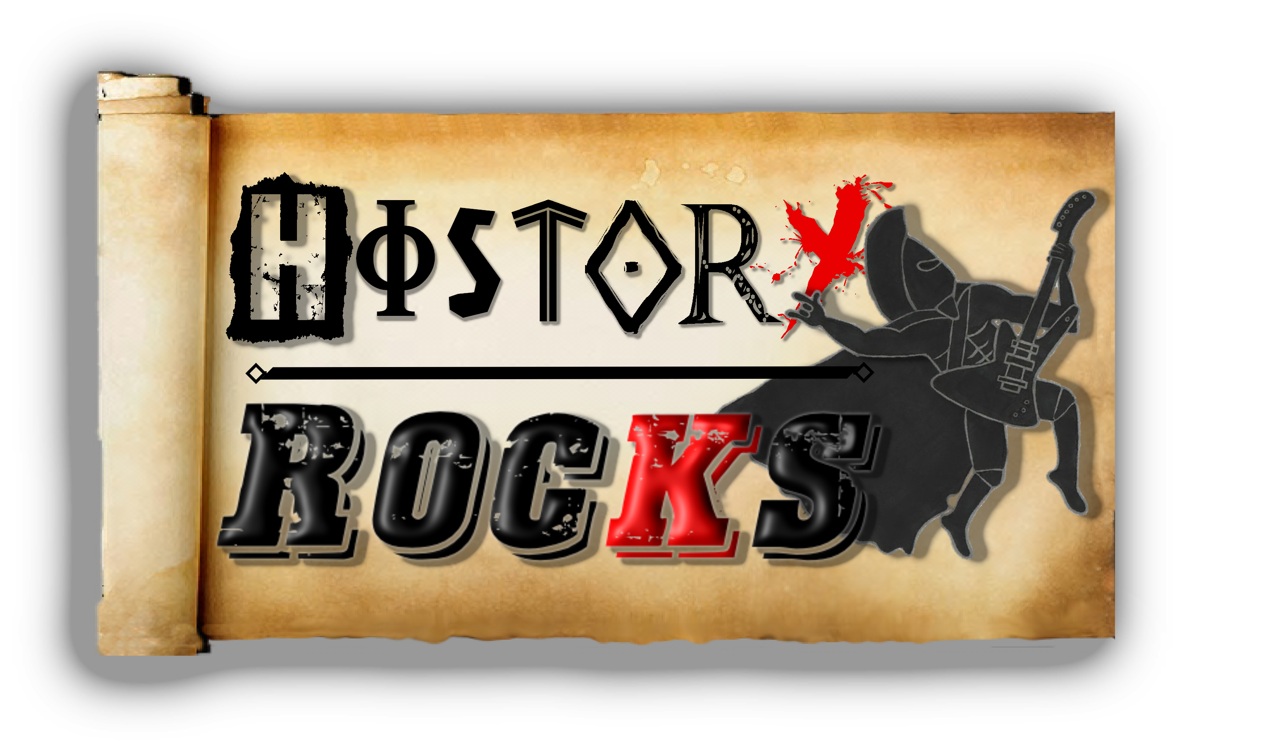**Science - Reflection**

**Light hits the things**

**And it bounces all around**

**Chorus**

**There are some things**

**That you should know**

**These things help us see**

**And helps stuff glow**

**Light bounces off**

**Of off some stuff**

**Into our eyes**

**So we can see enough**

**Light hits the things**

**And it bounces all around**

**Chorus**

**And it’s called reflection**

**Light projection**

**No rejection**

**And it’s called reflection**

**Materials best to reflect the light**

**Are smooth and they’re shiny**

**And they’re hard and they’re bright**

**The ones the light always rejects**

**Are dull and they’re soft**

**And they don’t reflect**

**Light hits the things**

**And it bounces all around**

**Chorus**