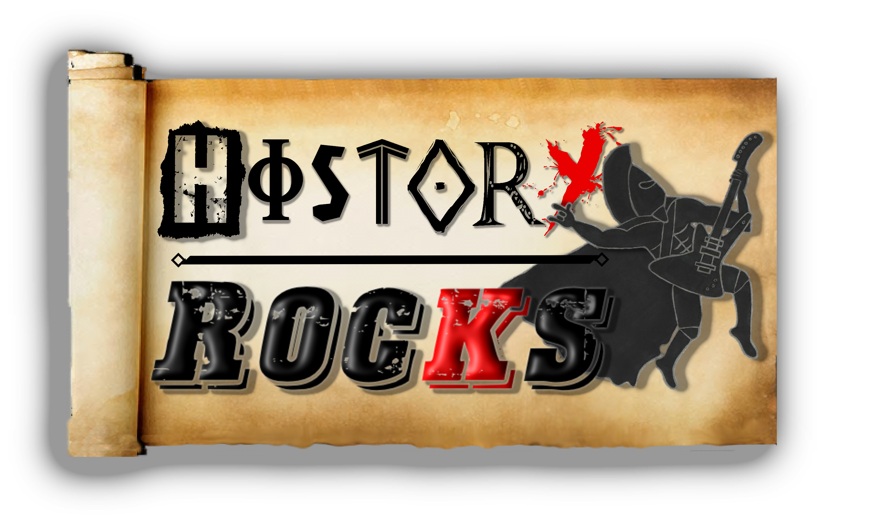
Egyptians – Mummies and Mummification
When you answer
For your crimes or
Any wickedness
That you do

Chorus

Bridge
Now we’re ready, wrap you up in linen
We cover you from head to toe
Using upwards of two hundred meters
Place a mask on you made of gold

We’ll give you the treatment, so you can behold
The preserved remains of Egyptian pharaohs

Place you into
Your own coffin
That we call a sarcophagus

Put your pets in
And all your jewellery
And your precious amulets

Chorus
Preserved – we keep you looking your best
Until the end of time
Reserved – we keep your heart in your chest
And leave your body to dry

We’ll take your innards
Just for beginners
And please them in
A canopic jar

We’ll make your body
All super salty
What we do
Really is bizarre

Chorus
Mummies, Mummies, oh what a sight!
We’re doing this for the afterlife
Mummies, mummies, oh what a fright
They’ll take away your appetite

Retrieve – we get your brain through your nose
With a hook on a stick
Believe – the gods will never oppose
If your brain don’t tick

Wear a beetle
Over your heart now
Cos it will stop it
From speaking true

