Place Name | Food and Drink Collected | Special Items Collected |  | Did you lose anyone and how?
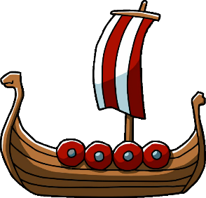
Viking Explorers Note Sheet
Use this sheet to help record the places that you choose to visit and the items that you acquire from your trip to provide at your feast.

Place Name | Food and Drink Collected | Special Items Collected |  | Did you lose anyone and how?
Place Name | Food and Drink Collected | Special Items Collected |  | Did you lose anyone and how?

Now use this information to write about the feast you have to celebrate your return from your travels. Make sure to say where you got your items from and whether you lost anyone there or not.

